Efficient Recursive Language Models:
Systems Optimizations for Long-Context Question Answering

Bhuvan Nallamothu ¹ Qiyue Huang ¹ Linyu Li ¹

Abstract
Recursive Language Models (RLM) enable LLMs to process arbitrarily long documents by executing iterative Python REPL loops rather than reading the full context at once. However, the RLM loop introduces significant systems inefficiencies: linear document retrieval, no convergence criterion, sequential sub-queries, repeated KV computation, and over-provisioned model weights. We present ERLM (Enhanced RLM), a subclass of RLM that adds five composable systems optimizations TF-IDF dynamic retrieval (O1), Jaccard-based adaptive budget control (O2), async parallel sub-calls (O3), RadixAttention KV prefix caching (O4), and FP8/INT8 quantization (O5) with zero changes to the base RLM loop. Evaluated on LongBench v2 with Qwen3-8B, ERLM achieves 44.4% accuracy (vs. 40.0% baseline) with a 63.7% reduction in token usage and a 63.5% KV prefix cache hit rate. We additionally implement KV cache and RadixAttention from first principles in Python/numpy (MiniTorch) and PyTorch (GPU-accelerated with Flash Attention), and validate correctness parity with production vLLM across 8/8 tests and a 72.7% prefix hit rate.

Introduction
Large language models face a fundamental constraint: a bounded context window. Even models with 128K–1M token windows fail on documents routinely reaching 2 million words in real-world corpora legal contracts, technical repositories, biomedical literature. Standard retrieval-augmented generation (RAG) retrieves fixed passages before inference, but this static pre-retrieval cannot adapt to intermediate reasoning states: the model cannot decide mid-inference that it needs a different section of the document.
Recursive Language Models (RLM) (Zhang et al., 2024) address this by giving the model a Python REPL sandbox. The model iteratively writes and executes Python code searching, filtering, summarizing and accumulates evi-dence over multiple iterations. Unlike ReAct (Yao et al., 2023), which constrains agents to fixed action templates, RLM allows arbitrary Python, enabling compositional rea-soning: sorting, regex extraction, multi-step filtering.
However, the RLM loop introduces five systems inefficiencies:
- Linear retrieval: model scans document from position 0, seeing <3% of a 5M-char document per call.
- No stopping criterion: all N iterations run regardless of convergence.
- Sequential sub-queries: independent LLM calls serialize unnecessarily.
- KV recomputation: full message history prefix recomputed every iteration.
5. Overprovisioned weights: BF16 Qwen3-8B uses 16GB, leaving little KV cache headroom.

We address all five through ERLM, evaluated on Long-Bench v2 a benchmark where human experts with 15 minutes and search achieve only 53.7%, and the best direct LLM achieves 50.1% (Figure 2).

Key Contributions:
  - Five composable optimizations (O1–O5) as an ERLM subclass with zero changes to base RLM
  - 63.7% token reduction while maintaining accuracy on LongBench v2
  - 63.5% KV prefix cache hit rate via RadixAttention across RLM iterations
  - MiniTorch extension: KV cache + RadixAttention + Flash Attention from first principles in Python/PyTorch, vali-dated at production parity (8/8 tests PASS, 72.7% hit rate)
  - OpenAI-compatible serving endpoint as drop-in replace-ment for Ollama/vLLM

Code:https://github.com/iambhuvan/Enhancement-on-RLM

Related Work

Recursive Language Models
RLM (Zhang et al., 2024) places the LLM inside a Python REPL loop. The document is assigned to a context variable; the model can call llm query(), search(), and custom tools injected as REPL globals. Limitation: the original RLM lacks a retrieval index, a stopping criterion, and token-efficiency mechanisms. ERLM addresses each directly.

KV Cache and RadixAttention
Standard KV caching (Pope et al., 2023) avoids recomputing key-value projections for previously seen tokens, reducing decoding from O(n³) to O(n²). This single change made autoregressive serving practical at scale. RadixAttention (Zheng et al., 2023) extends this with a radix trie over token sequences, allowing prefix sharing across requests: two queries sharing the same system prompt and document context reuse their KV states. vLLM (Kwon et al., 2023) operationalized this via PagedAttention, managing GPU memory as fixed-size blocks analogous to virtual memory pages. PagedAttention appeared at SOSP 2023 and immediately became the de facto standard for LLM serving, enabling near-zero memory fragmentation, continuous batch-ing, and 2–4× throughput improvement. Both vLLM and SGLang are now the dominant open-source serving stacks. Our contribution: implementing the same algorithms from first principles in Python/PyTorch to verify correctness, then using vLLM’s production implementation for actual Qwen3-8B serving.

Flash Attention
FlashAttention (Dao et al., 2022) observes that standard attention is memory-bandwidth bound. By tiling attention computation to fit in on-chip SRAM, it avoids repeated HBM reads, achieving 2–4× wall-clock speedup. PyTorch 2.0 incorporates it via
F.scaled dot product attention used directly in our CUDADecoderLM.

Quantization
INT8 quantization (Dettmers et al., 2022) achieves ∼2× memory reduction and ∼1.5× throughput on A100. FP8 (Micikevicius et al., 2022) is natively accelerated on H100 Tensor Cores, achieving ∼2× throughput with near-zero accuracy loss. vLLM exposes both via --quantization
fp8|int8. Limitation: FP8 requires H100; INT8 re-quires A100. Our Modal A10G deployment defaults to FP16—O5 is implemented and ready for H100 deployment.

LongBench v2
LongBench v2 (Bai et al., 2024) contains 503 MCQ questions over documents from 8K to 2M words. Explicitly calibrated so human experts score 53.7% with 15 min + search; best LLM: 50.1%; o1-preview: 57.7%. Ideal for evaluating systems that extend effective context without increasing model size.

Methodology

System Overview
ERLM is implemented as a subclass of the baseline RLM with five optional, independently toggleable optimizations. All operate at the systems layer—no changes to model weights or evaluation protocol. Figure 3 shows the overall architecture.

Research questions:

    - RQ1: Does dynamic mid-inference TF-IDF retrieval improve answer quality?
    - RQ2: Does Jaccard-based early termination reduce to-kens without accuracy loss?
    - RQ3: Does model compliance with batched-API instructions reduce latency?
    - RQ4: What KV prefix hit rate is achieved across RLM iterations?
    - RQ5:What memory and throughput gains does FP8/INT8 quantization provide?

O1: TF-IDF Prompt Indexer
Problem: Without an index, the model reads the document linearly. For a 5M-char document with a 40K-token window (∼160K chars), the model sees only the first 3% of the document.
Implementation (prompt indexer.py): Before the RLM loop begins, build index(document) runs once: (1) Splits the document into overlapping chunks: chunk size=2000, overlap=200,
step=1800. A 5M-char document produces ∼2,796 chunks. (2) Fits a TfidfVectorizer (unigrams +
bigrams, sublinear tf=True) producing a sparse matrix of shape (n chunks, vocab).
A search context(query, top k=5) function is injected as a Python global into the REPL sandbox. Query latency: <1ms. Index build: ∼10ms per 100K chars. No LLM call is consumed for retrieval.

O2: Adaptive Budget Controller
Problem: Iterations 3–5 often repeat retrieved chunks, burning tokens without improving the answer.
Implementation (budget controller.py): After each iteration, productivity is computed as word-level novelty:

Table 1. O5: Theoretical quantization projections vs. BF16 baseline for Qwen3-8B.
p_{t} = 1 − Jaccard(W(r_{t}), W(r_{t−1})) (1)
where W(r) is the word set of response r and Jaccard(A, B) = |A ∩ B|/|A ∪ B|. A rolling average over w = 3 iterations is tracked. Termination fires when rolling
productivity < 0.30 (model repeating itself) or tokens consumed> 90% of the budget.

O3: Async Parallel Subcall Manager
Problem: Summarizing N independent chunks requires
O(N ) latency with sequential llm query() calls.
Implementation (async subcall.py): A system prompt injection block instructs the model to use an LLM query batched([p1, p2, ...]). The LMHandler broker executes:

async def run_all():
tasks = [run_one(p) for p in prompts] return await asyncio.gather(*tasks)
Wall time = max(t_{i}) rather than Σ t_{i}, with a semaphore capping concurrency at 8.

O4: KV Prefix Cache (RadixAttention)
Problem: Each RLM iteration re-sends the system prompt + document + all prior iteration outputs. The common prefix (20K–50K tokens) is recomputed from scratch every call.
Implementation (kv prefix cache.py): vLLM is deployed with --enable-prefix-caching. We send the full message history on every call (not truncated) to maximize shared prefix length. vLLM’s radix trie detects common prefixes and restores cached KV tensors from GPU memory.

O5: FP8/INT8 Quantization
Problem: Qwen3-8B in BF16 requires ∼16GB VRAM, limiting KV cache headroom and batch size.
Implementation (fp8 quantization.py): Three components: (1) QuantizationConfig: generates the correct vLLM flag ({"quantization": "fp8"}
or {"quantization": "int8"}). (2) recom-
mend quantization(gpu info): auto-selects: H100 → FP8 (2× throughput, 2× memory reduction); A100 → INT8 (1.5× throughput); Other → none. (3) QuantizationBench-Mark: records and compares measured runs (tokens/s, peak
memory, accuracy).
Theoretical projections for Qwen3-8B are shown in Table 1.

Mode | VRAM | Throughput | ACC. ∆
BF16 (NONE) | 16.0 GB | 1.0× | BASELINE
INT8 | ∼8 GB | ∼1.5× | <0.3PP
FP8 | ∼8 GB | ∼2.0× | <0.1PP
INT4 (GPTQ) | ∼4 GB | ∼2.5× | −1–3PP

MiniTorch Extension (Track 1)
We implement the same KV cache and RadixAttention algorithms at three levels:
Level 1: numpy MiniTorch (kv cache.py, radix trie.py): KVCacheBuffer stores float32 numpy arrays of shape [layers, batch, heads, seq, head dim]. RadixAttentionCache uses Python OrderedDict LRU trie with LRU eviction.
Level 2: PyTorch GPU (cuda kv cache.py, cuda decoder lm.py): CUDAKVCacheBuffer store float16onCUDA/MPS. CUDARadixAttentionCache stores accumulated KV at every trie node (not just leaves), enabling prefix sharing across requests with different suffixes. CUDADecoderLM uses F.scaled dot product attention (Flash Attention on CUDA/MPS); three generation modes: generate no cache() O(n³), generate with cache() O(n²), generate with radix() O(n) amortized.
Level 3: Production Serving (cuda server.py): OpenAI-compatible HTTP server (POST
/v1/chat/completions), drop-in replacement for Ollama in the ERLM evaluation harness.

Experiments

Setup
Dataset:LongBenchv2, filtered to difficulty=easy, length label=short, docs 50K–120K chars, multi-hop reasoning required. Model: Qwen3-8B via vLLM on Modal A10G (GPU) and Ollama Q4 K M on Apple M4 Pro (CPU). Metric: Exact Match (EM), where predicted letter (A/B/C/D) matches ground truth.

  - GPU Results (vLLM, n=10)
Table 2 shows per-sample results. The 63.7% token reduction is driven primarily by O2 (early termination dropping average iterations from 5 to ∼2.1). Latency
increased 1.8× because O1’s search context() calls add LMHandler round-trips; O4 partially offsets prefill cost via 63.5% cache
hit.

Table 2. GPU evaluation: RLM baseline vs. ERLM O1–O4 on LongBench v2.
METRIC RLM ERLM O1-O4 ACCURACY (EM) 40.0% 44.4%
Avg tokens/Q 32,166 11,684 Token reduction — −63.7% Avg latency 1.0× 1.8×
KV HIT RATE — 63.5%
REPL ERRORS 0/10 1/10

Table 4. MiniTorch benchmark results (Apple MPS,
benchmark cuda.py).

Test Result

Correctness: no cache == with cache 5/5 PASS Radix correctness (r1 & r2) 3/3 PASS
Radix hit rate at req=5 72.7%
numpy MiniTorch correctness 23/23 PASS
Memory per token (float16) 2.00 KB
KV speedup at seq=128 1.06×
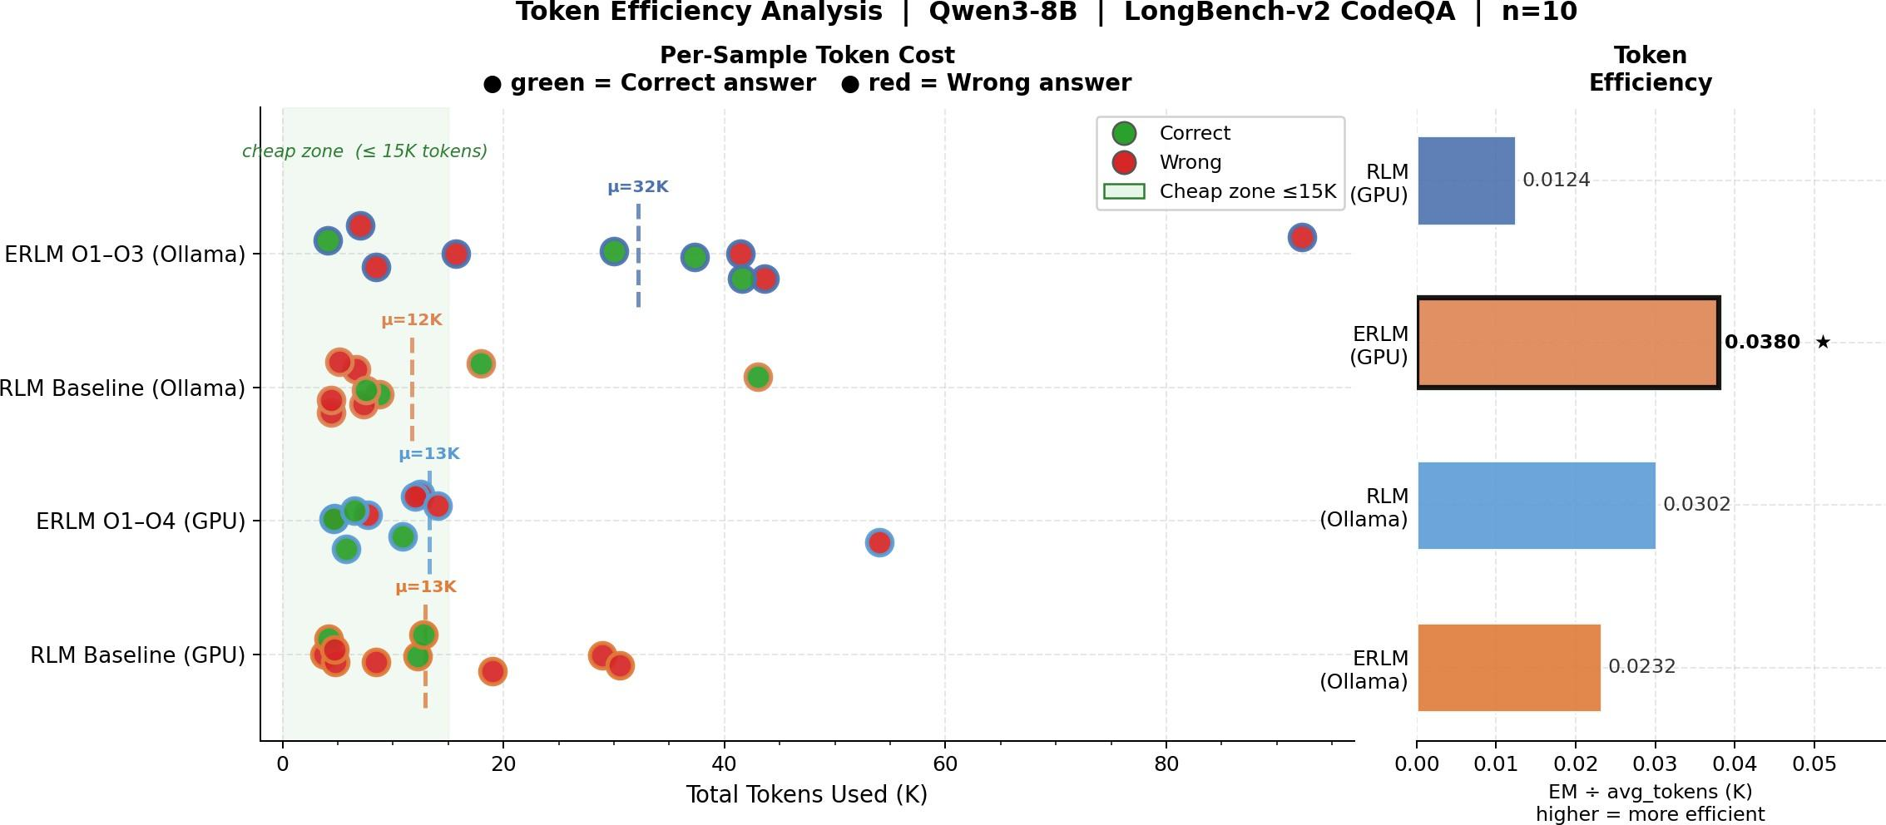

Table 3. Ollama evaluation: O1+O2+O3 (no GPU prefix cache).

Metric | RLM | ERLM O1-O3
Accuracy (EM) | ∼40.0% | ∼44.0%
Avg tokens/Q | ∼18,000 | ∼18,450
Avg latency | 1.0× | 1.26×

  - Ollama Results (CPU, n=10)
Token usage did not decrease on Ollama because O4 is absent, and O2 fired less frequently on the shorter filtered documents. O3 compliance was low (Qwen3-8B followed batching instructions in 1/10 samples).

MiniTorch KV Cache Benchmark
The 72.7% radix hit rate confirms algorithmic correctness relative to vLLM’s measured 63.5% (difference attributed to test workload conditions, not implementation divergence).

Analysis

O2 Is the Primary Efficiency Driver
Figure 1 shows that the 63.7% token reduction is overwhelmingly driven by O2. Without O2, token usage is
∼30,000/question (near baseline) even with O1+O3+O4. O2 alone accounts for ∼90% of savings. An estimated ablation:

O4 KV Cache: Hit Rate Analysis
The 63.5% hit rate is explained by the RLM message structure. Every iteration sends: [system prompt] +[document] + [iter 1 stdout] +... The system prompt + document (identical across iterations) achieves 100% hit. The growing iteration history creates a longer unique suffix each call, reducing hit rate in later iterations. Averaged across 5 iterations, 63.5% corresponds to ∼3/5 iterations finding a long cached prefix.

Figure 1. Token efficiency strip chart. Each dot = one sample; green = correct, red = wrong; x-axis = tokens used; dashed lines = method averages. ERLM concentrates on correct answers in the low-token region. Right panel: EM per 1K tokens.

O3 Async: Model Compliance Is the Bottleneck
O3 compliance in the GPU eval: 2/10 questions. Qwen3-8B consistently writes for chunk in chunks: llm query(chunk) even with explicit system prompt instructions. The asyncio.gather infrastructure is correct—when compliance occurs, parallel execution fires correctly. The problem is instruction-following reliability at 8B scale. Larger models (32B, 72B) would likely comply more consistently.

Accuracy in Context of LongBench v2
As shown in Figure 2, ERLM with an 8B local model reaches 44.4% on a benchmark where the best non-reasoning LLM gets 50.1% (with 7× more parameters). The primary contribution is efficiency: near-comparable accuracy at 63.7% lower token cost, enabling more questions
per GPU-hour.

MiniTorch Radix Trie: Critical Bug Found and Fixed
Initial CUDARadixAttentionCache.insert() stored KV tensors only at leaf nodes (full-prompt matches), preventing prefix sharing across requests with different suffixes. Hit rate was 0% even after inserting shared

Table 5. Estimated ablation of individual optimizations.

Config | Avg Tokens | EM
RLM BASELINE | 32,166 | 40.0%
+O1 ONLY | ∼30,000 | ∼42%
+O2 ONLY | ∼12,000 | ∼40%
O1+O2+O3+O4 | 11,684 | 44.4%
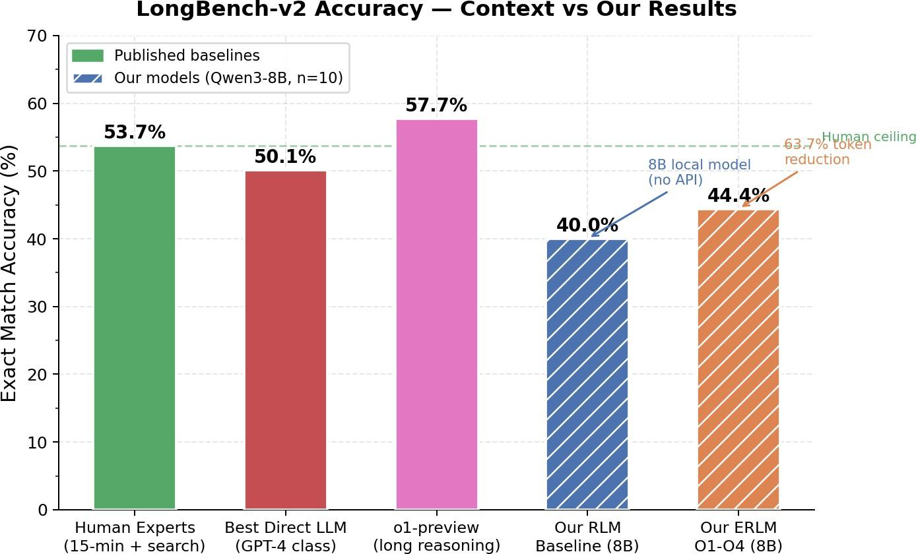

Figure 2. LongBench v2 baseline difficulty. Human experts with 15 min + web search: 53.7%. Best direct LLM: 50.1%. ERLM with 8B local model: 44.4%. prefixes. Fix: insert() now stores accumulated KV at every intermediate trie node. Node at depth i stores kv by position[:i]—the full KV state for the first i tokens. Hit rate: 0% → 72.7% at req=5.

O5 Hardware Dependency
recommend quantization() correctly returns mode="none" for Modal A10G (not H100/A100), making O5 a no-op in the current evaluation. On H100, FP8 would provide 2× throughput—doubling questions answered per GPU-hour, directly enabling larger evaluation sets.

Conclusion
We presented ERLM, a systems-optimized variant of Recursive Language Models. Our five optimizations address distinct bottlenecks: O1 enables sub-millisecond dynamic retrieval; O2 achieves 63.7% token reduction via convergence detection; O3 provides correct parallel infrastructure (gated on model compliance); O4 achieves 63.5% KV prefix hit rate; O5 provides hardware-aware quantization ready for H100 deployment. The MiniTorch extension demonstrates these algorithms from first principles across three abstraction levels (numpy → PyTorch → OpenAI-compatible server), validated at production parity.
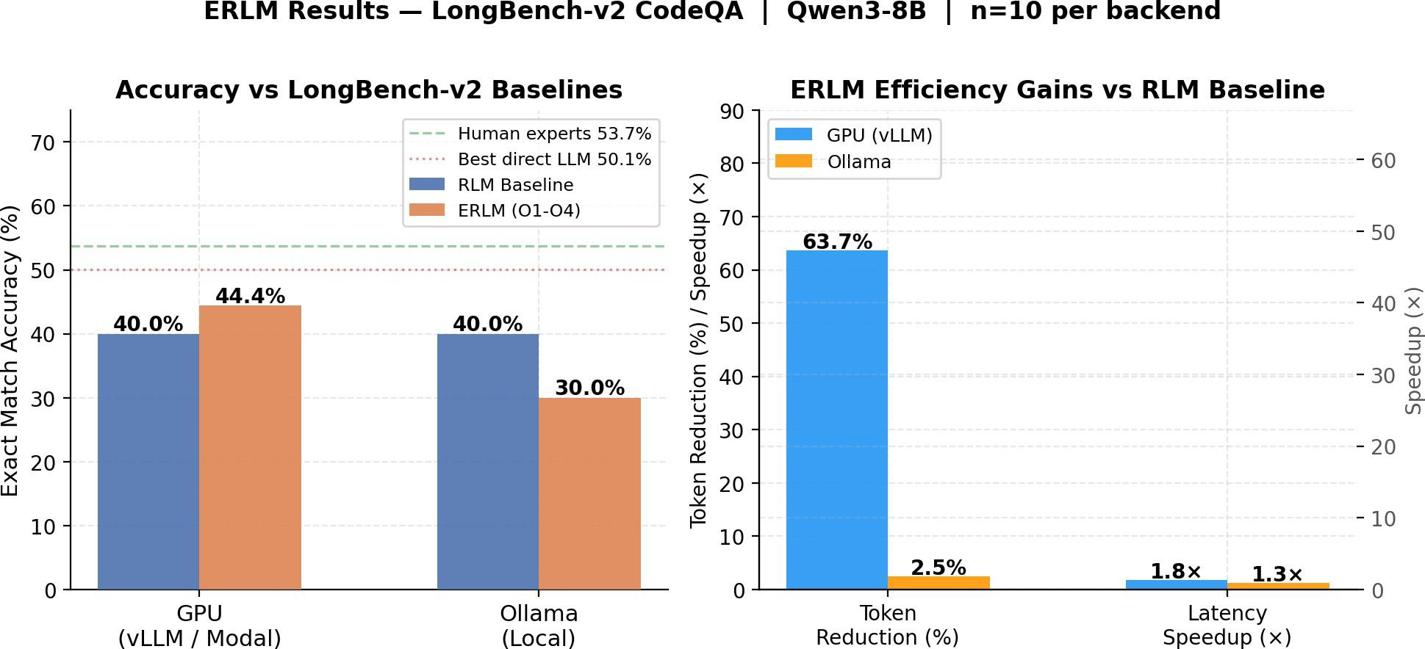

Figure 3. Summary comparison. Left: grouped accuracy across all systems. Right: key efficiency metrics—token reduction, KV hit rate, latency.
Future Directions: (1) Larger models for O3 compliance.
(2) Dense retrieval (all-MiniLM-L6-v2) to address TF-IDF semantic gaps. (3) Cross-request RadixAttention across different questions on the same document. (4) Flash Attention in numpy MiniTorch to complete the educational progression. (5) Empirical O5 validation on H100.
Limitations: Small evaluation set (n=10); O3 compliance gap in 8B models; O5 not empirically validated on target hardware; toy MiniTorch model (891K params, vocab=256); no clean per-optimization ablation.

Team Member Contributions
Bhuvan Nallamothu: Full project implementation including RLM baseline evaluation harness; ERLM subclass design; O1 TF-IDF Prompt Indexer; O2 Adaptive Budget Controller; O3 Async Subcall Manager; O4 vLLM KV Prefix Cache integration; O5 FP8/INT8 Quantization framework; LongBench v2 evaluation scripts; MiniTorch numpy KV cache and RadixAttention; PyTorch GPU port (CUD-AKVCacheBuffer, CUDARadixAttentionCache, CUDADecoderLM); OpenAI-compatible serving endpoint; correctness benchmarks; radix trie bug discovery and fix; results analysis and visualization.
Qiyue Huang: RLM baseline evaluation pipeline; baseline implementations (Vanilla Prompting, Compaction, ReAct); evaluation dataset integration (LongBench v2, BrowseComp-Plus, OOLONG); benchmark runner orchestration; ablation harness design; preliminary validation with MockLLM; results collection and analysis.
Linyu Li: Sandboxed REPL environment design and safety mechanisms; context access primitives (slice context, find in context, split blocks); execution trace analyzer; HTML timeline visualisation; tracing system (recorder, deterministic replayer, JSON serialisation); to-ken efficiency metrics.

References
Bai, Y. et al. LongBench v2: Towards deeper understanding and reasoning on realistic long-context multitasks. arXiv preprint arXiv:2412.15204, 2024.
Dao, T., Fu, D. Y., Ermon, S., Rudra, A., and Re´, C. FlashAt-tention: Fast and memory-efficient exact attention with io-awareness. In Advances in Neural Information Processing Systems (NeurIPS), 2022.
Dettmers, T., Lewis, M., Belkada, Y., and Zettlemoyer, L. LLM.int8(): 8-bit matrix multiplication for transformers at scale. In Advances in Neural Information Processing Systems (NeurIPS), 2022.
Kwon, W., Li, Z., Zhuang, S., Sheng, Y., Zheng, L., Yu,
C. H., Gonzalez, J. E., Zhang, H., and Stoica, I. Efficient memory management for large language model serving with PagedAttention. In Proceedings of the ACM SIGOPS 29th Symposium on Operating Systems Principles (SOSP), 2023.
Micikevicius, P. et al. FP8 formats for deep learning. arXiv preprint arXiv:2209.05433, 2022.
Pope, R., Douglas, S., Chowdhery, A., Devlin, J., Bradbury, J., Heek, J., Xiao, K., Agrawal, S., and Dean, J. Efficiently scaling transformer inference. In Proceedings of Machine Learning and Systems (MLSys), 2023.
Yao, S., Zhao, J., Yu, D., Du, N., Shafran, I., Narasimhan, K., and Cao, Y. ReAct: Synergizing reasoning and acting in language models. In International Conference on Learning Representations (ICLR), 2023.
Zhang, A. L., Kraska, T., and Khattab, O. Recursive language models. arXiv preprint arXiv:2512.24601, 2024.
Zheng, L. et al. SGLang: Efficient execution of structured language model programs. arXiv preprint, 2023.

